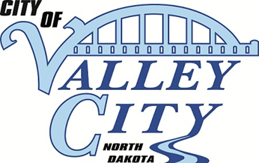
City of Valley City, North Dakota
Application for
Permit to Sell L.P. Gas

FOR PERIOD: January 1, 2024 – December 31, 2024
The undersigned hereby makes application for a license to the City of Valley City, North Dakota, and agrees to comply with the requirements of City Ordinances pertaining thereto.

Name of Business:
Owner:
Business Address:
Mailing Address:
City, State Zip Code:
Phone Number:
Email Address:
Today’s Date:
New applicants or applicants with changes to the following shall file the following with the City Auditor:
Previous experience
Trade references

All applicants shall file the following with the City Auditor by December 13th as part of this application:

Certificate of Liability Insurance

LICENSE FEE: $1000 if initial application, make checks payable to City of Valley City
$500 if renewal application

RETURN TO: Valley City Auditor
254 2nd Ave NE
Valley City, ND 58072
Phone: (701) 845 – 1700

For City Use Only
Reviewed by Fire Department Approved Denied
Signature
Reviewed by Commission Approved Denied

